**CYCLIC STBC FOR MIMO SYSTEMS**

**INTRODUCTION:**

The aim of this project is to design cyclic space-time block codes for the MIMO systems by using exhaustive computer searching method, for a fixed L, to optimize the coding gain and compare the normalized coding gain and spectral efficiency for different L values and for integer and non-integer optimal parameter(u) values.

**IMPLEMENTATION:**

1. Cyclic space-time block codes for MIMO systems with two transmit antennas (*Mt* = 2) is designed by exhaustive computer searching:

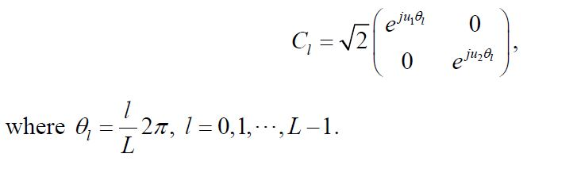

2. For different values of L, we search the optimal parameters *u1,u2* ⊂ { 0,1,2,….,L-1 }, such that the coding gain is maximized. The corresponding coding gain is also computed along with the spectral efficiency which is directly proportional to ‘L’.

3. The above step is repeated for non-integer values of the optimal parameters and the corresponding values of the coding gain and normalized coding gain, and the spectral efficiency are computed.

**INSTRUCTIONS:**

When the code is executed, you will be prompted to enter the values of L which should be an integer and the increment value for the optimal parameter(u). The complexity of the execution increases for decrease in the increment value.

**OBSERVATION:**

1. Since the spectral efficiency is directly proportional to the logarithm of L, we can see that the value increases correspondingly with increase in L for constant T.

2. As the value of L increases, the value of normalized coding gain keeps on decreasing as they are inversely proportional.

3. We can observe that, the normalized coding gain is better, in most cases, for non-integer optimal parameters when compared to integer values of u.